**3D Movement**

**Step 1: Setting Scene**

Start by adding two game objects, a Plane and a cube.

Position the cube at 0.5.

Afterwards create two materials, one called plane and the other called cube.

Assign different colours to both materials and add them to their respective object.

**Step 2: Cube movement**

Create a new script and call it “Cube” after creating it add it to the cube.

In the update function add a transform function dot translate, then add a parenthesis.

Inside the parenthesis will be the Vector 3 movements, so the X, Y and Z axis.

For the X axis create an Input.GetAxis function labled Horizontal then times that times time.deltaTime, for the Y axis just specify it as 0f whilst for the Z axis copy the X function but replace the word Horizontal for Vertical.



**Step 3: Move Speed**

The cube should now be able to move but it moves quite slowly.

To fix this we need to create a public float variable called moveSpeed.

In the start function set the function moveSpeed equal to 1f.

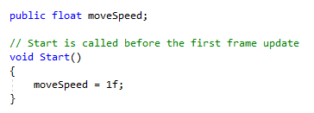

After the moveSpeed has been created, add it to the update function infront of the Input.GetAxis functions, make sure to multiply the moveSpeed times the Input.GetAxis.



**Step 4: Unity**

Return to unity and you should see on the cube script a variable moveSpeed appear, you can customize it to set a desired speed for your character.

You can also increase the moveSpeed value on the code, for example set it as 10f rather than 1.

**End of the Tutorial.**